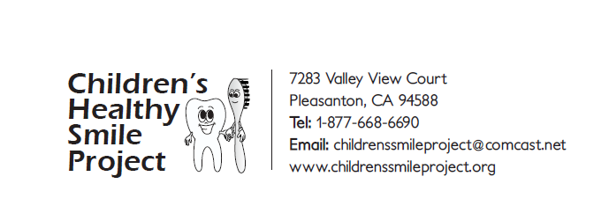
6183 Corte Santiago
Pleasanton, CA 94566
Tel: 1-925-353-8832
Email: Childrenssmileproject@comcast.net
www.childrenssmileproject.org

1-925-353-8832
Acknowledgement of Volunteer Service

We would like to acknowledge the volunteer service provided by [ProjLocal] in updating Children’s Healthy Smile Project’s website. Nihaal recently approached our organization and offered to improve/update our website: www.childrenssmileproject.org which had not been attended to because of COVID and other issues. Nihaal is a junior in a local high school and lives in Pleasanton, CA. He has experience in Internet related programming and Internet websites.
I am pleased to say [ProjLocal] reviewed our current website and an interim draft which has been dormant for several years. [ProjLocal] rapidly modified the interim draft, reorganizing and reformatting the site, greatly improving the appearance and logical flow of information. The site went “live” and was successfully launched. After review, some relatively minor improvements were suggested, which were quickly implemented.
We wish to thank Nihaal for reaching out to support a local nonprofit which has limited funds and utilizes all donations to support their programs. He is a very talented individual and is a credit to his family.

Rosario Milelli
Chief Operating Officer
Children’s Healthy Smile Project

*references to specific ProjLocal members are replaced with “ProjLocal” in brackets

